Carbohydrates and Glycobiology

Carbohydrates are aldehyde or ketone derivatives of polyhydroxy alcohols containing at least three carbon atoms with the general formula (CH₂O)_{n}
They are moderately reduced compounds (some oxygen associated with them) which can be converted into energy (ATP) quickly
Uses
1) Energy storage, fuel, intermediates of metabolism
2) Structural - DNA and RNA, cell walls in plants (cellulose), arthropods skeleton (chitin)
3) Recognition - attached to lipids and proteins (blood types on red blood cells = antigens)
Monosaccharides - suffix "ose" is used to designate sugars
- Building blocks --> polysaccharides (macromolecules)
- D-Configuration is the most common in sugars synthesized by living organisms
  - D assignment is based on the configuration of the chiral carbon furthest from the "anomeric" carbon
    - C-1 in aldoses & C-2 in ketoses
- Two major monosaccharide classes
  - Aldoses
  - Ketoses
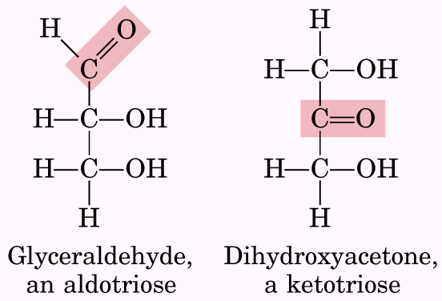
- Aldoses
  - Structures based on D-glyceraldehyde which is the simplest aldose
    - D is determined by the asymmetric carbon FURTHEST AWAY from the aldehyde and is drawn to the RIGHT!
  - Aldoses contain an aldehyde group
  - Have 1-4 chiral centers per molecule
  - Be familiar with both open chain & ring forms
  - Know structures of glucose
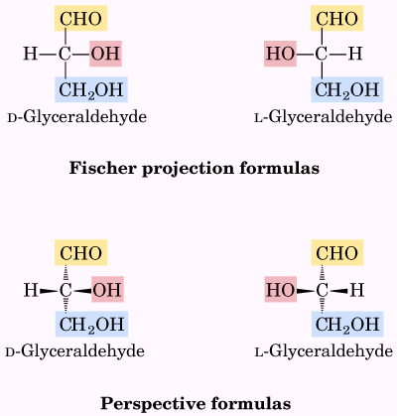
D-glyceraldehyde L-glyceraldehyde
- Ketoses
  - Structures based on dihydroxyacetone (simplest ketose)
    - D is determined by the asymmetric carbon FURTHEST AWAY from the ketone and is drawn to the RIGHT!
  - Contain a carbonyl group
  - Have 1,2 or 3 chiral carbons per molecule
  - Know the structures of ribulose & fructose
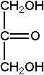
dihydroxyacetone
Nomenclature
  - The number of carbons are indicated by the prefix for the sugar such that hexoses (e.g., glucose and fructose) contain 6 carbons and pentoses contain 5 carbons.
    - triose 3
    - tetrose 4
    - pentose 5
    - hexose 6
    - heptose 7

- Carbohydrates are rich in stereoisomerism
  - Enantiomers = isomers that are perfect mirror images (i.e., D- and L- glyceraldehyde)
  - Diastereoisomers = not mirror images (i.e., D-erythrose and D-threose)
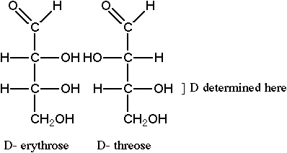 | 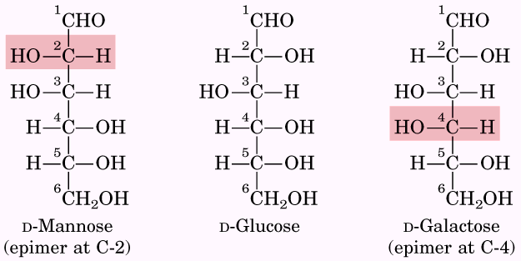

  - Epimers = isomers that differ at a single asymmetric carbon --- Hexose examples
    - Glucose vs mannose at carbon 2
    - Gucose vs galactose at carbon 4
- CONFIGURATIONS OF CARBOHYDRATES:
  - Asymmetric carbons are those which have four different chemical groups attached.
    - Glucose has four different asymmetric carbons (#2,3,4,5).
      - Look at epimers of glucose
        - Allose, altrose, and mannose
    - Carbons in sugars are numbered beginning at the end nearest the aldehyde or ketone group.
    - The "D" or "L" designation for a sugar designates the arrangement of the atoms around the asymmetric carbon farthest from the aldehyde or ketone.
    - Most sugars in humans are D-sugars.
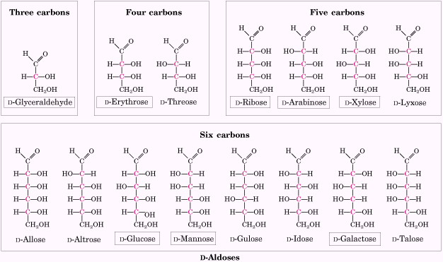
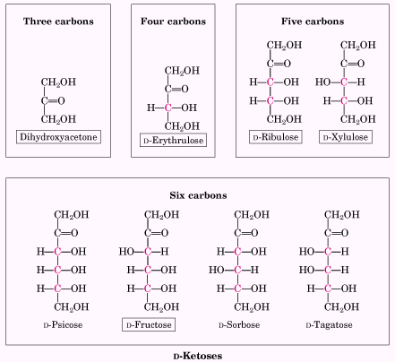
- Anomeric carbon is the new asymmetric carbon formed when an alcohol (COH) group in a monosaccharide reacts with the aldehyde or ketone to form a cyclic compound.
  - The anomeric carbon can either be α or β, depending on the orientation of the alcohol group on the anomeric carbon relative to the CH₂OH group.
  - Glucose forms a 6-membered pyranose ring consisting of 5 carbons and 1 oxygen.
  - Fructose forms a 5-membered furanose ring containing one less carbon.
    - Found in fruits
- In solution, monosaccharides (aldoses & ketoses) with 5 or more carbons are most stable in their "ring" form
  - In the ring form, the carbonyl carbon becomes covalently bound to another OH-group within the chain.
  - Carbonyl carbon becomes the "anomeric" carbon after cyclization
  - Most common ring structures
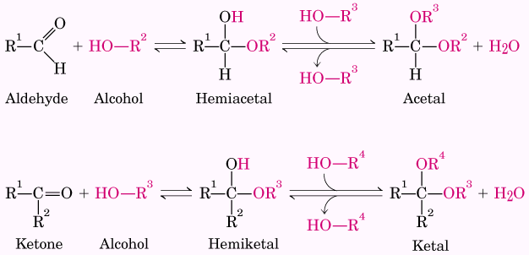  Formation of hemiacetals and hemiketals | 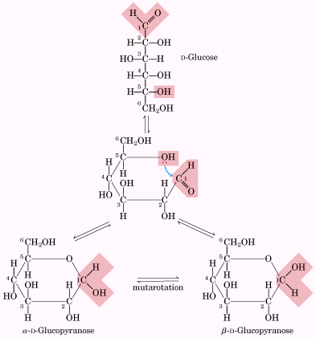  Formation of the two cyclic forms of D-glucose
    - pyranose ring - 6-membered ring (5- or 6-carbon monosaccharides)(see figure with glucose ring formation above)
      - Glucose = six-carbon aldose
      - C-1 reacts with C-5 OH to form pyranose ring
      - Conformation of hydroxyl on carbon 1
        - α (below plane of ring)
        - β (above plane of ring)
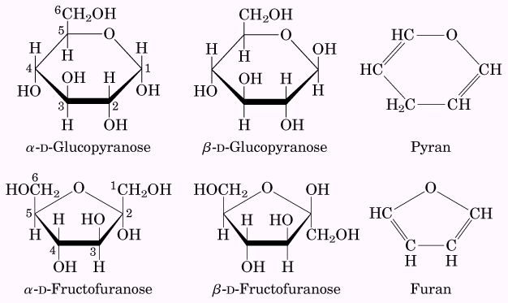  Pyranoses and furanoses | 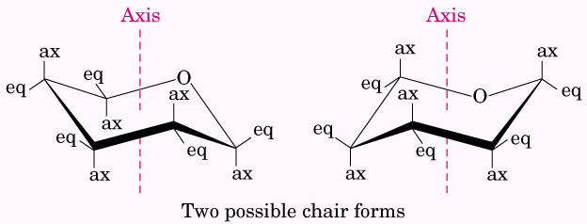  Conformational formulas of pyranoses

    - furanose ring - 5-membered ring (most 5-carbon monosaccharides)
      - Fructose = six-carbon ketose
      - C-2 reacts with C-5 OH to form furanose ring
      - C-1 reacts with C-5 OH to form pyranose ring
      - Conformations
  - Anomers or Anomeric Carbon = After cyclization, the anomeric OH-group can be above, or below, the plane of the ring
    - α-D sugars have the OH-group on the anomeric carbon below the plane of the ring
    - β-D sugars have the OH-group on the anomeric carbon above the plane of the ring in glucopyranose
    - The β form (β-D glucopyranose) is the preferred form (62%), with α-D-glucopyranose accounting for the remaining 38%.
  - α and β forms interconvert in water through straight-chain forms(mutarotation)
    - D-glucose in solution is 1/3 α and 2/3 β (1% open chain) - these are anomers
  - Chair vs boat form of pyranose ring
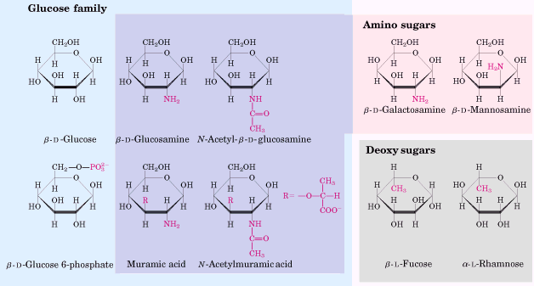
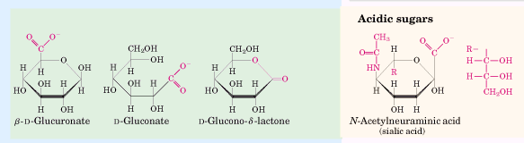
Some hexose derivatives important in biology

Monosaccharides are reducing agents
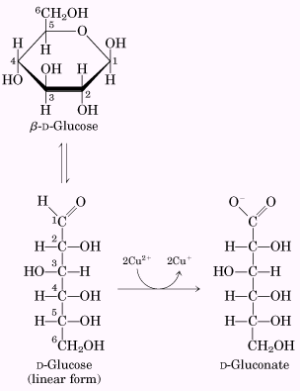  Sugars as reducing agents | Tollens Reagent  Benedict Reagent

  - After entering a cell, sugars are immediately phosphorylated by addition of phosphate usually derived from ATP.
    - Such phosphorylated sugars are key intermediates in metabolic pathways and can interact in electrostatic interactions
    - One important reason for phosphorylating sugars is to prevent them from leaving the cell. Phosphate groups accomplish this because they have a high negative charge associated with them readily cross cell membranes. Some phosphorylated sugars are highly reactive and can transfer phosphate to ADP to form ATP.
Complex Carbohydrates
- How are the monomers linked together?
  - Use the chemistry of hydroxyl and carbonyl groups
    - -O- Glycosidic bonds (oxygen) analog of the peptide bond = removal of water
    - no mutarotation since opening and re-closing of the ring form no longer possible
    - broken down by glycosidases via addition of water

Disaccharides
- Two monosaccharides joined by a O-glycosidic bond
- Glycosidic bond - catalyzed by hydrolase (dehydration reaction) to form R-O-R linkage
  - Glycosidic bonds hold together the monosaccharides in a polysaccharide. The bond is formed when the anomeric hydroxyl group condenses with an alcohol group on a second monosaccharide.
- Anomeric OH-group from one sugar reacts with an OH-group on another sugar
- Reaction generally leaves one "anomeric" carbon
- Disaccharides common in nature
Some common disaccharides
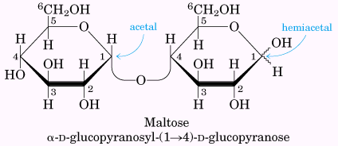 | 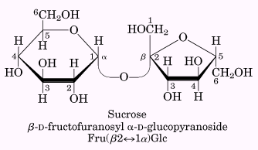
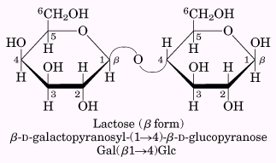 | 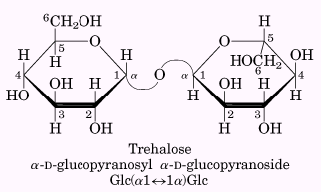

  - sucrose - disaccharide containing fructose + glucose linked via an α (1->2) linkage (no free anomeric carbon) glucose α (1->2)-β-fructose
    - alpha-D-glucopyranosyl - (1-->2) - beta-D-fructofuranoside
  - lactose (milk sugar) - a disaccharide consisting of galactose + glucose linked by a β (1->4) linkage (free anomeric carbon) - galactose β (1->4)glucose
    - β -D-galactopyranosyl - (1-->4) - α-D-glucopyranose
    - Lactose intolerance
      - In the intestine lactase hydrolyzes lactose, a disaccharide, to galactose and glucose by cleaving a ß-1,4-galactosidic bond.
      - Approximately one in 4 adults is deficient in this enzyme leading to lactose intolerance.
        - Up to 90% of Asians and Africans may be lactase-deficient as adults. Lactose accumulates in the intestine due to poor absorption. Bacteria produce metabolites of lactose leading to fluid influx into the intestine. Clinical symptoms include distension, nausea, cramping, watery diarrhea. Lactose must be removed from the diet.
  - maltose - 2 glucopyranose units joined by an α (1->4) linkage (free anomeric carbon)
    - α form - glucose α (1->4)- α -glucose
    - β form - glucose α (1->4)-β-glucose
      - α -D-glucopyranosyl - (1-->4) - α -D-glucopyranose

Oligosaccharides - 2-8 monosaccharides linked by glycosidic bonds

Polysaccharides (glycans) - polymers of monosaccharides (8 or more) linked by glycosidic bonds. In contrast to the other biomolecules, sugars can form branched as well as linear polymers.
Sugar polymers of high molecular weight (can be over 10⁶ residues)(dextrans are α -1,6 bonds)

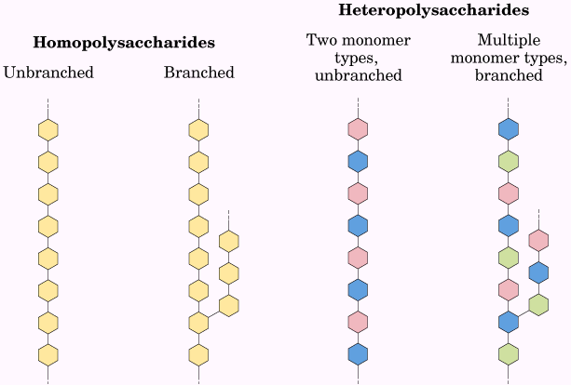 | Amylose and amylopectin, the polysaccharide of starch  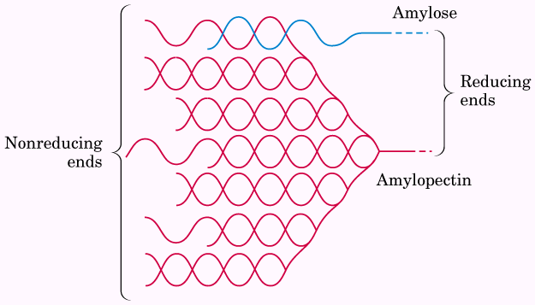

Storage (energy) Homopolysaccharides - polysaccharides composed of only one type of sugar involved
- Starch (plants) - consists of two types of glucose homopolysaccharides (storage form of glucose)
  - Structural forms
    - α -amylose - α (1->4) linked glucopyranose polymer
      - Unbranched, irregular helical coiled conformation
    - Amylopectin - α (1->4) glucopyranose polymer with α (1->6) branch points
      - Branches ~ every 30th bond
      - Up to 10⁶ residues
  - Starch is plant primary food reserve and is deposited in insoluble granules
  - Breakdown of dietary starch in mammals
    - enzyme α-amylase (in saliva and pancreas) breaks internal α -1,4 linkages to give maltose, maltotriose, and α -dextrin (α 1,6's and α 1,4's)
    - chain length reduced from 1000s to 8 glucose residues
    - we cannot cleave α (1->6)

- Glycogen (animals) - storage form of glucose in cytoplasm of most cells, but particularly high in liver & skeletal muscles of animals (stored as granules)
  - Glycogen is similar to amylopectin, but more highly branched
    - α (1->4) linked glucopyranose polymer with α (1->6) branch points ~ every 10th bond
  - Glycogen requires two enzymes for degradation
    - One to hydrolyze α (1->4 linkages (α -amylase in digestive system or glycogen phosphorylases in cells)
    - One to hydrolyze α (1->6) linkages (debranching enzyme in cells)
  - Glycogenolysis in liver and release of free glucose into blood stream when blood glucose drops
  - Glycogenesis in liver when blood glucose is high by transport of glucose into liver and synthesis of glycogen
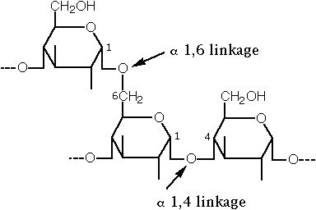
Structural homopolysaccharides
- Cellulose (plants) - β (1->4) linked glucopyranose polymer - one of the most resistant natural polymers made
  - plant cell walls
    - maintains shape
    - withstands osmotic pressure changes
  - as many as 15,000 D-glucose residues linked by β-1,4 linkages (we can't digest this linkage)
    - ruminants have protozoa and bacteria that contain cellulase (mutualistic symbiosis)
  - unbranched - gives straight chain
  - stabilized by hydrogen bonds
  - makes long fibrils with high tensile strength
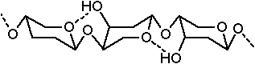
- Chitin (invertebrate exoskeleton) - β (1->4) linked N-acetylglucosamine polymer
  - Therefore, like cellulose except N-acetyl group at C-2 in residues
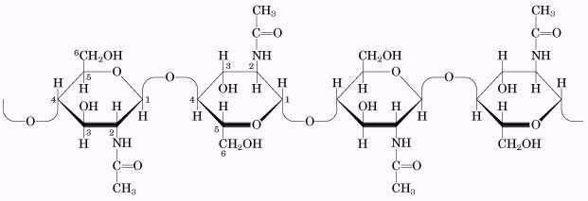
- Cell walls of fungi & algae are also a polymer of N-acetylglucosamine with β 1,4 unbranched linkages - is very strong
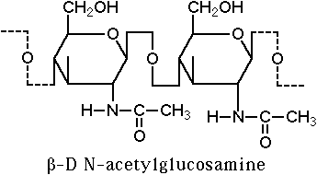

Heteropolysaccharides
- Polysaccharides composed of two or more types of monosaccharide units
  - Gycosaminoglycans consist of repeating disaccharide units with negatively charged groups
  - Many are linked to proteins and are known as proteoglycans
  - Important in connective tissue, basement membrane, synovial fluid of joints, and in the extracellular matrix between cells -- Examples
    - Hyaluronic acid or hyaluronate
      - β (1->3) linked glucuronic (COOH in 6 positions) and N-acetyl-D-glucosamine polymer
    - Chondroitin 6-sulfate
    - Heparin (anticoagulant)
    - Keratin sulfate
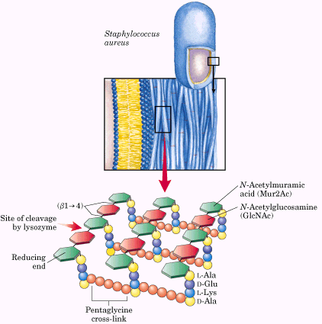  Peptidoglycan | 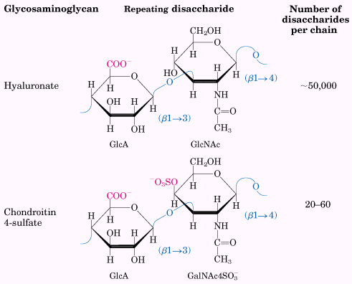  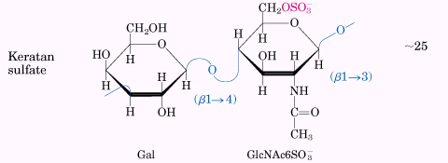  Repeating units of some common glycosaminoglycans of extracellular matrix
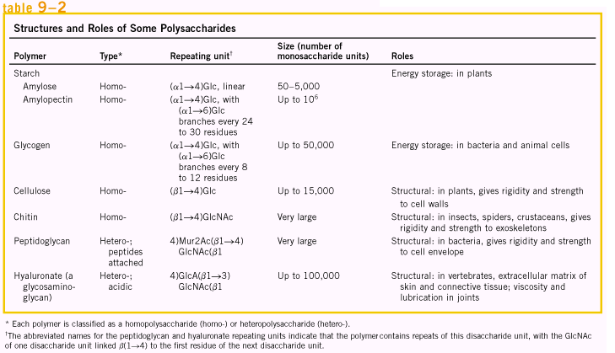

OTHER COMPLEX CARBOHYDRATES
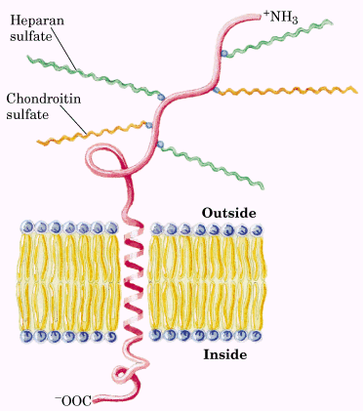  Proteoglycan structure of an integral membrane protein | 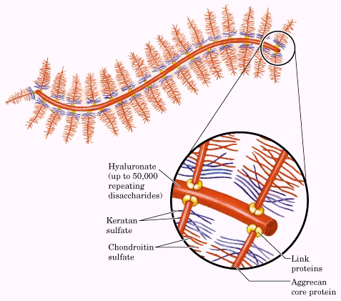  A proteoglycan aggregate of the extracellular matrix
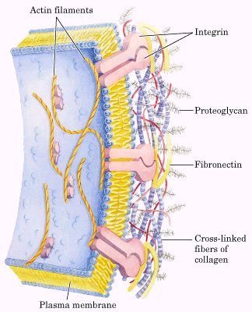  Interactions between cells and extracellular matrix | 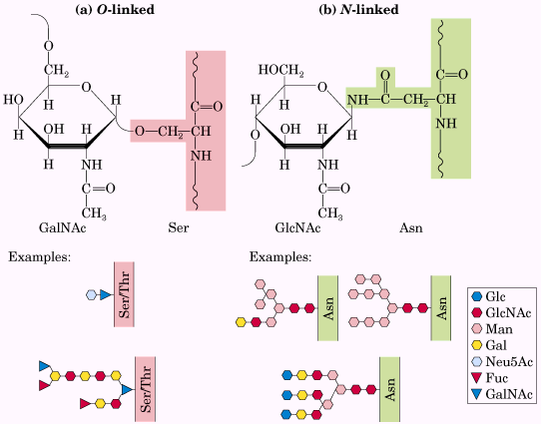  Oligosaccharide linkages in glycoproteins

- Glycoproteins ---> CHO residues on Proteins = Involved in Cell Recognition/Cell Adhesion
- Modified monosaccharides (fucose and sialic acid) are often attached at β bends or β-turns
- O-glycosylation = Polysaccharides are attached to serine or theronine OH forming -O-glycosidic bonds
- Disaccharide core of galactose β 1,3 N-acetylgalactosamine
- Can be branched CHO from this basal unit
- N-glycosylation = Polysaccharides are attached to asparagine R-group amine forming -N-glycosidic bonds
- N-acetylglucoseamine is the first sugar in the unit with branched CHO attached
- N-linked carbohydrates have a common core:
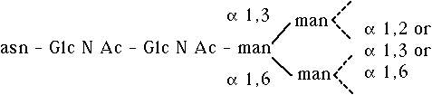
- Another carbohydrate found on proteins is sialic acid
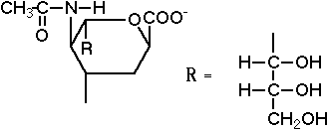
- Common linkage is -gal-sia by an α - 2,3 linkage
- Possible role of sialic acid: protein recycling
- New proteins in blood for example, immunoglobins and some hormones, are synthesized with sialic acids present.
  - With time, sialic acids are removed (sialidase).
  - Enzyme recognized asialoglycoprotein, binds it, and takes it up into liver cells where it is digested.
- Other roles include:
  - cell binding
  - cell-cell recognition
Nucletide-linked Sugars
- UDP-glucose
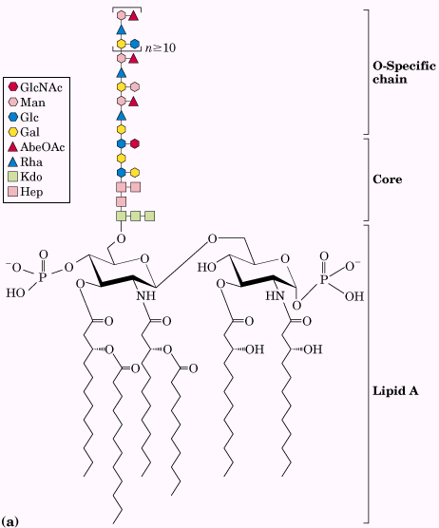  Bacterial Lipoposaccharides | 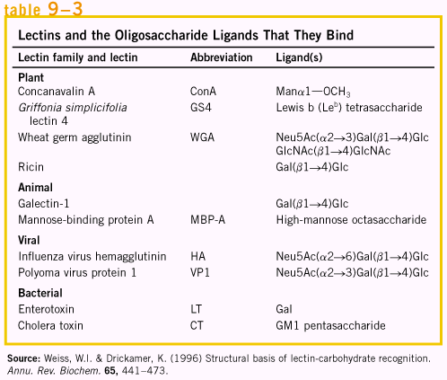

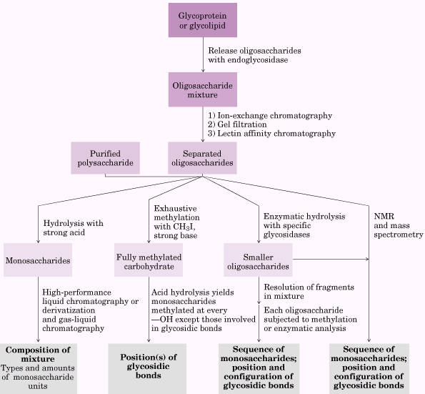

Methods of carbohydrate analysis

SACCHARIDES
Definition: Polyhydroxy aldehydes or ketones; also called sugars or carbohydrates
aldose- made from aldehyde
ketose- made from ketone
Four important roles in living organisms:
1) provide energy through their oxidation
2) serve as stored form of energy
3) supply carbon for biosynthesis
4) form a part of the structural components of some cells and tissues
Anomeric carbon- original aldehyde of ketone carbon in non-ring form
Anomers- saccharides that differ in configuration only at the anomeric carbon
Epimers- saccharides that differ in configuration at only one carbon other than the anomeric
Mutarotation- change in specific rotation as anomers interchange via free aldehyde or ketone form in solution
Reducing sugars- yield positive Tollens, Benedict or Fehlings tests; must be hemiacetal or hemiketal
Hemiacetal- 1º ether/alcohol
Acetal- 1ºdi-ether
Hemiketal- 2º ether/alcohol
Ketal- 2º di-ether
Important Monosaccharides (reducing)
Glucose, aldohexose, blood sugar (dextrose)
Galactose, aldohexose , component of milk sugar, cerebrosides, blood antigens A & B
Fructose, ketohexose, fruit sugar (levulose)
Ribose, aldopentose, RNA component
2-Deoxyribose, aldopentose, DNA component lacks -OH at carbon # 2
Important Disaccharides
Cellobiose, [glucose-O-glucose -1,4] (from cellulose), reducing
Maltose, [glucose-O-glucose -1,4] (malting hops), reducing
Lactose, [galactose-O-glucose -1,4] (milk sugar), reducing
Sucrose, [glucose-O-fructose] , (table sugar), non-reducing
Important Polysaccharides
Cellulose ,glucose polymer, -glycosidic bond, plant structure
Amylose , glucose polymer, -glycosidic bond, plant starch
Amylopectin, glucose polymer, -glycosidic bond, cross linked every 20-30 units, plant starch
Glycogen, glucose polymer, -glycosidic bond, cross linked every 8-12 units, animal starch
Property........Mono- & di-saccharides.......... Polysaccharides
Molecular mass............................ low ....................................... high
Taste ........................................... sweet ......... ....................... tasteless
Soluble in water?......................... yes .......................................... no
Size ................. small, can pass through membranes ........... large, cannot pass
Reducing? ................................ yes, except sucrose ..................... no
Mutarotation? ......................... yes, except sucrose ....................... no

